1. Demonstrate that you have created S3 bucket

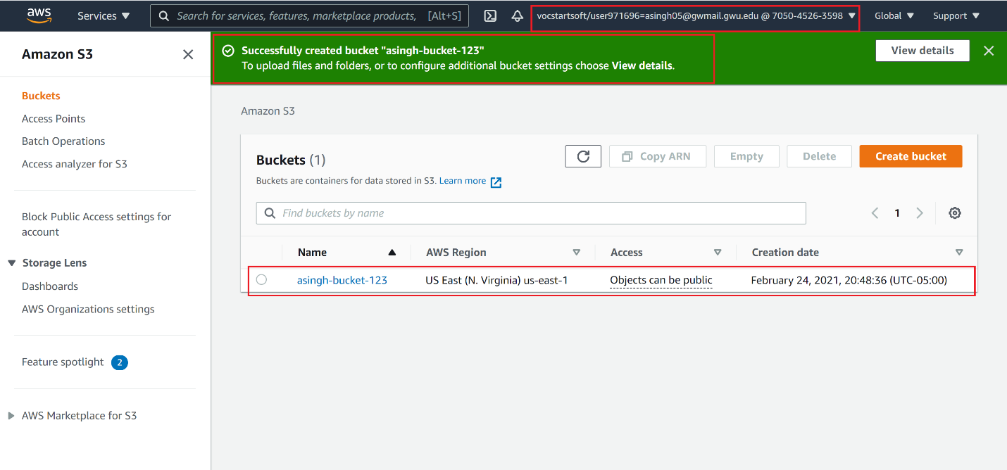

2. Demonstrate that you have applied JSON policy to allow public access to all objects in your S3 bucket

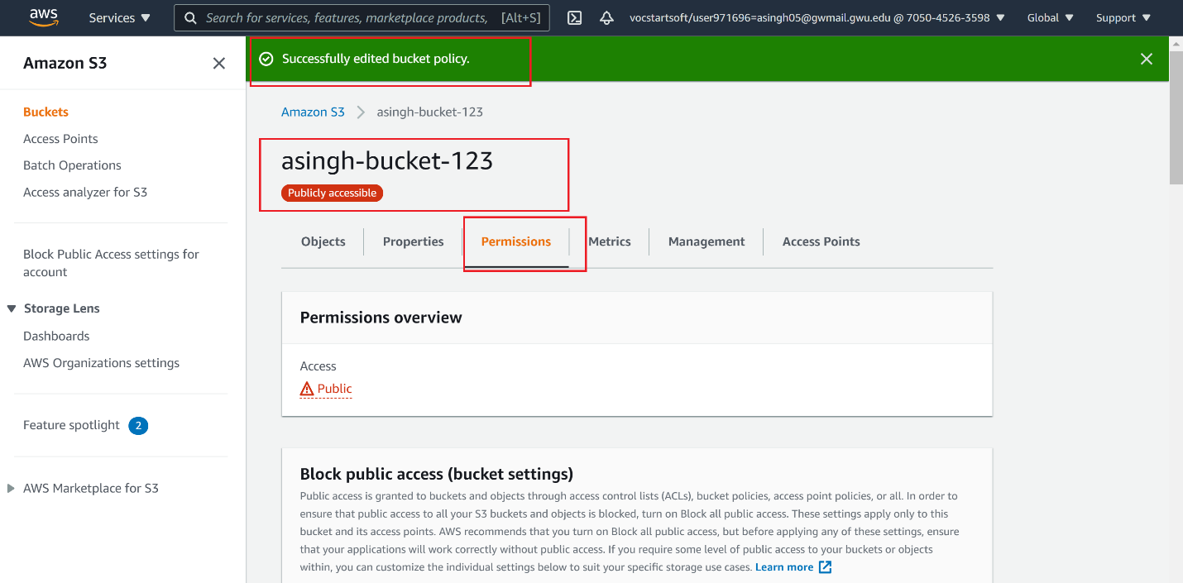

3. Demonstrate that you have uploaded 5 files and 2 folders into your S3 bucket

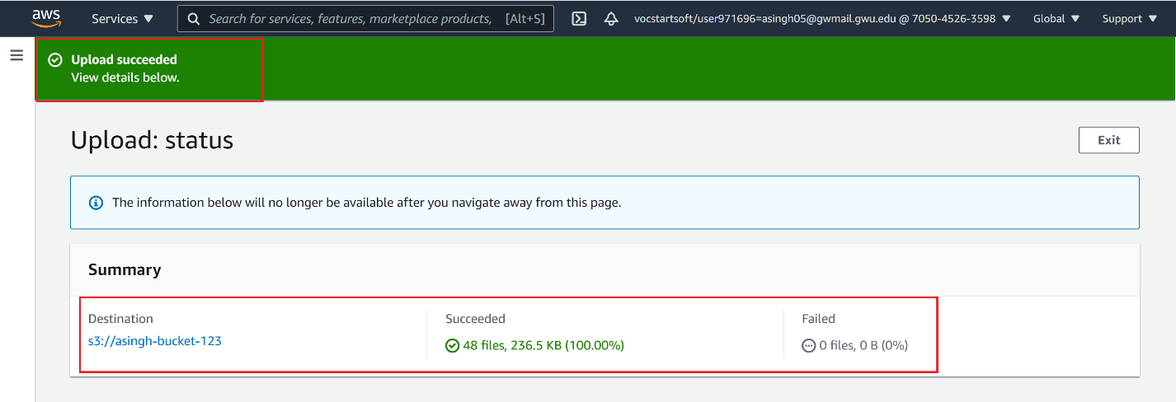

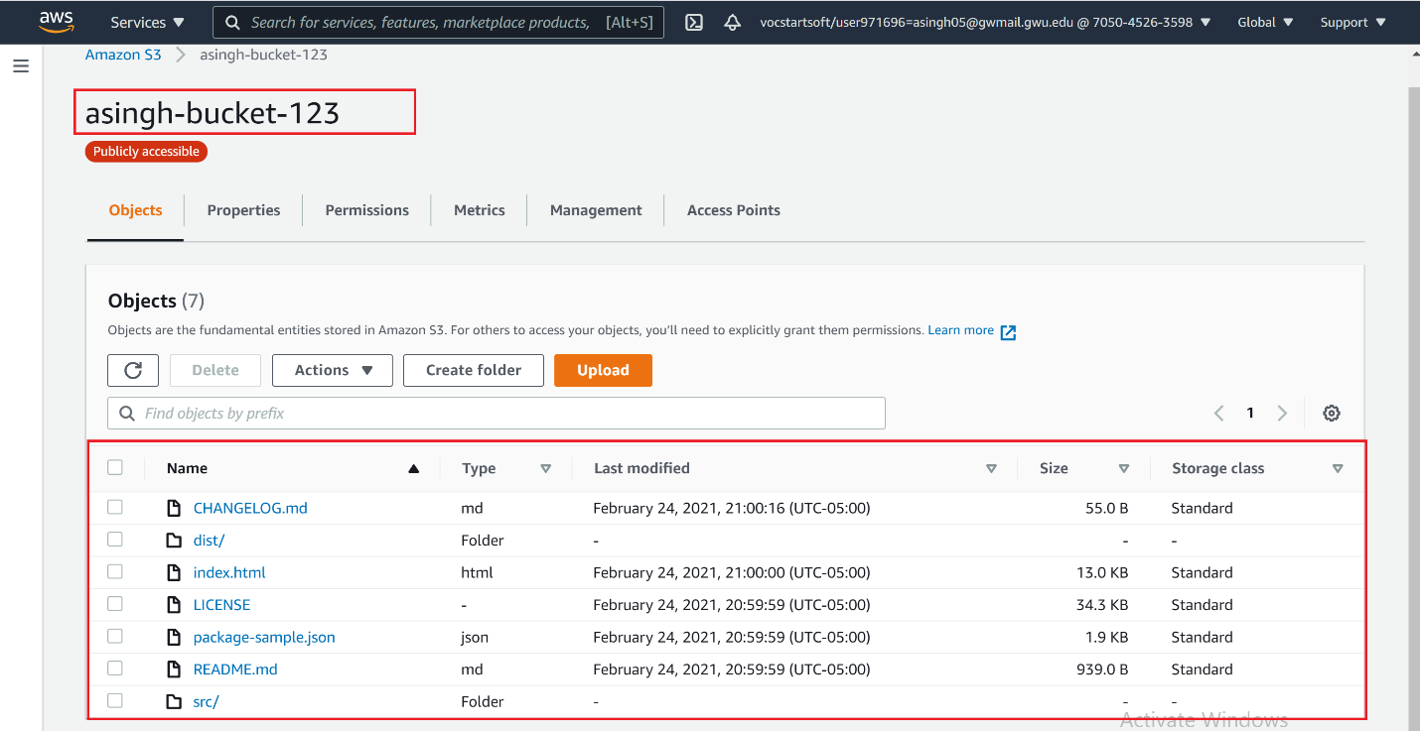

4. Demonstarte that you can lauch your website from the browser

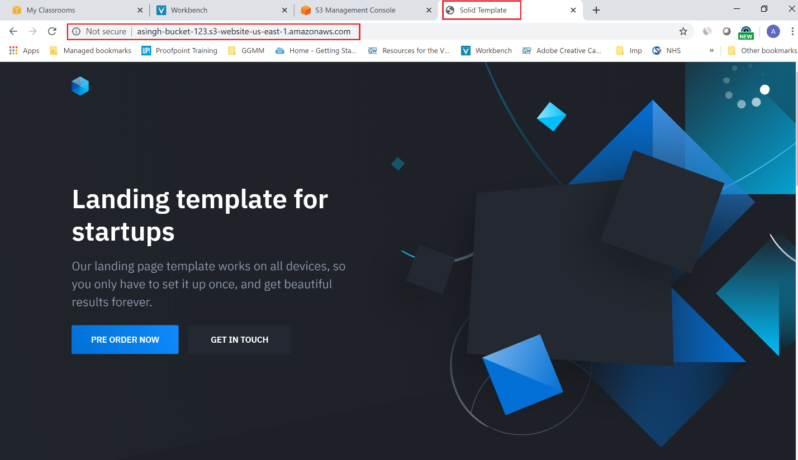

5. Demonsrate that you have created ZipImages Lambda function

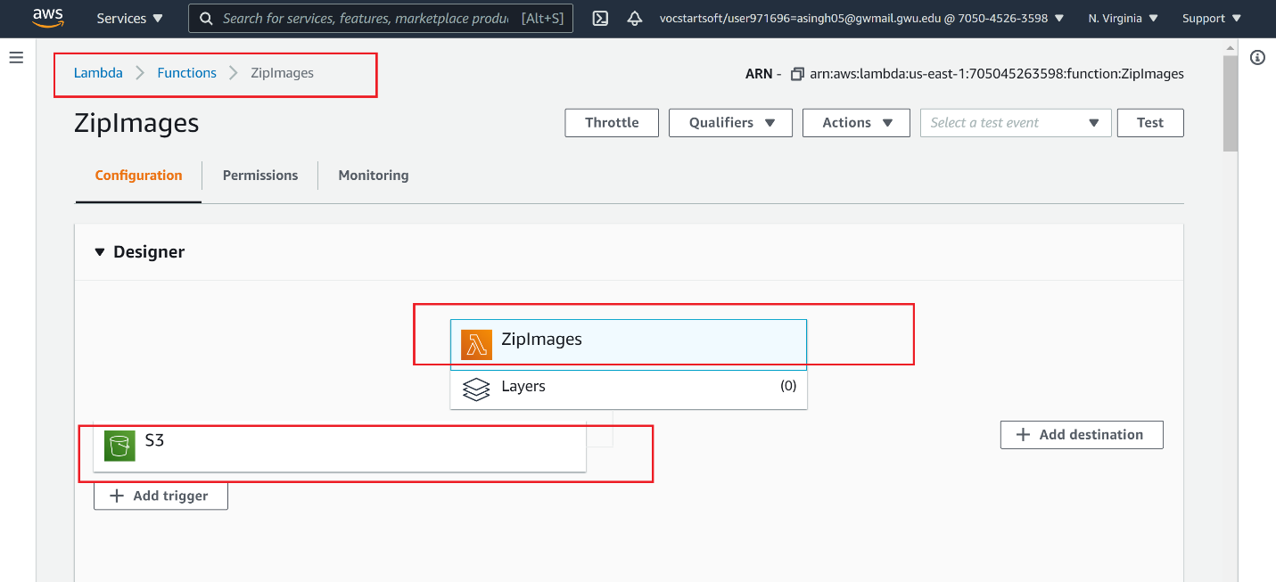

6. Demonstrate that after you have uploaded gixxer.png you get zipped version of it in /zip folder

